Pre=processing
-------------------------------------------------------------------------------------------------
label
0 35028
1 37106
dtype: int64
-------------------------------------------------------------------------------------------------
Number of observations removed for null values in title or rating columns: 558
-------------------------------------------------------------------------------------------------
Number of observations removed for duplicate values: 9233
Counter({'en': 60048, 'de': 814, 'fr': 212, 'es': 204, 'ru': 153, 'ca': 152, 'it': 116, 'nl': 96, 'af': 73, 'da': 72, 'no': 68, 'id': 64, 'ro': 50, 'pt': 41, 'et': 27, 'sv': 24, 'tl': 21, 'ar': 19, 'vi': 15, 'lt': 11, 'so': 10, 'tr': 10, 'error': 7, 'hr': 7, 'cy': 6, 'fi': 4, 'pl': 3, 'sl': 3, 'sw': 3, 'bg': 3, 'el': 2, 'lv': 1, 'fa': 1, 'sq': 1, 'zh-cn': 1, 'hu': 1})
-------------------------------------------------------------------------------------------------
Number of titles removed for not being in English: 209
-------------------------------------------------------------------------------------------------
Minimum tokens: 3
Maximum tokens: 96
Average of tokens: 18.1779
Number of tokens per percentile: [12. 13. 15. 16. 17. 19. 20. 22. 25.]
Number of titles with more than 128 tokens: 0
Number of titles with more than 64 tokens: 3
Number of titles with more than 32 tokens: 1415
label
0 34404
1 27730
dtype: int64

Tuning pre-trained model
Some weights of BertForSequenceClassification were not initialized from the model checkpoint at bert-base-uncased and are newly initialized: ['classifier.bias', 'classifier.weight']
You should probably TRAIN this model on a down-stream task to be able to use it for predictions and inference.
Original sentence: LAW ENFORCEMENT ON HIGH ALERT Following Threats Against Cops And Whites On 9-11By #BlackLivesMatter And #FYF911 Terrorists [VIDEO]
Tokenized sentence: tensor([ 101, 2375, 7285, 2006, 2152, 9499, 2206, 8767, 2114, 10558,
1998, 12461, 2006, 1023, 1011, 2340, 3762, 1001, 2304, 3669,
6961, 18900, 3334, 1998, 1001, 1042, 2100, 2546, 2683, 14526,
15554, 1031, 2678, 1033, 102, 0, 0, 0, 0, 0,
0, 0, 0, 0, 0, 0, 0, 0, 0, 0,
0, 0, 0, 0, 0, 0, 0, 0, 0, 0,
0, 0, 0, 0])
Attention: tensor([1, 1, 1, 1, 1, 1, 1, 1, 1, 1, 1, 1, 1, 1, 1, 1, 1, 1, 1, 1, 1, 1, 1, 1,
1, 1, 1, 1, 1, 1, 1, 1, 1, 1, 1, 0, 0, 0, 0, 0, 0, 0, 0, 0, 0, 0, 0, 0,
0, 0, 0, 0, 0, 0, 0, 0, 0, 0, 0, 0, 0, 0, 0, 0])
Label: tensor(1)
49,707 sentences for training
6,213 sentences for validation
6,214 sentences for test

Model Training
======== Period 1 / 3 ========
Training...
Batch 40 of 1,554. Time elapsed: 0:06:53.
Batch 80 of 1,554. Time elapsed: 0:13:54.
Batch 120 of 1,554. Time elapsed: 0:21:15.
Batch 160 of 1,554. Time elapsed: 0:28:49.
Batch 200 of 1,554. Time elapsed: 0:37:10.
Batch 240 of 1,554. Time elapsed: 0:46:09.
Batch 280 of 1,554. Time elapsed: 0:55:39.
Batch 320 of 1,554. Time elapsed: 1:01:43.
Batch 360 of 1,554. Time elapsed: 1:08:16.
Batch 400 of 1,554. Time elapsed: 1:15:30.
Batch 440 of 1,554. Time elapsed: 1:22:24.
Batch 480 of 1,554. Time elapsed: 1:28:23.
Batch 520 of 1,554. Time elapsed: 1:34:13.
Batch 560 of 1,554. Time elapsed: 1:40:02.
Batch 600 of 1,554. Time elapsed: 1:45:53.
Batch 640 of 1,554. Time elapsed: 1:51:37.
Batch 680 of 1,554. Time elapsed: 1:57:22.
Batch 720 of 1,554. Time elapsed: 2:03:12.
Batch 760 of 1,554. Time elapsed: 2:09:04.
Batch 800 of 1,554. Time elapsed: 2:14:53.
Batch 840 of 1,554. Time elapsed: 2:20:39.
Batch 880 of 1,554. Time elapsed: 2:26:33.
Batch 920 of 1,554. Time elapsed: 2:32:26.
Batch 960 of 1,554. Time elapsed: 2:38:17.
Batch 1,000 of 1,554. Time elapsed: 2:44:09.
Batch 1,040 of 1,554. Time elapsed: 2:50:01.
Batch 1,080 of 1,554. Time elapsed: 2:55:53.
Batch 1,120 of 1,554. Time elapsed: 3:01:47.
Batch 1,160 of 1,554. Time elapsed: 3:07:38.
Batch 1,200 of 1,554. Time elapsed: 3:13:32.
Batch 1,240 of 1,554. Time elapsed: 3:19:23.
Batch 1,280 of 1,554. Time elapsed: 3:25:16.
Batch 1,320 of 1,554. Time elapsed: 3:31:10.
Batch 1,360 of 1,554. Time elapsed: 3:36:56.
Batch 1,400 of 1,554. Time elapsed: 3:42:48.
Batch 1,440 of 1,554. Time elapsed: 3:48:40.
Batch 1,480 of 1,554. Time elapsed: 3:54:30.
Batch 1,520 of 1,554. Time elapsed: 4:00:24.
Accuracy: 0.92
Average training loss: 0.19
Training period took: 4:05:18

Validating...
Accuracy: 0.95
Validation Loss: 0.14
Validation took: 0:08:35

======== Period 2 / 3 ========
Training...
Batch 40 of 1,554. Time elapsed: 0:05:50.
Batch 80 of 1,554. Time elapsed: 0:11:46.
Batch 120 of 1,554. Time elapsed: 0:17:41.
Batch 160 of 1,554. Time elapsed: 0:23:36.
Batch 200 of 1,554. Time elapsed: 0:29:33.
Batch 240 of 1,554. Time elapsed: 0:35:26.
Batch 280 of 1,554. Time elapsed: 0:41:20.
Batch 320 of 1,554. Time elapsed: 0:47:16.
Batch 360 of 1,554. Time elapsed: 0:53:04.
Batch 400 of 1,554. Time elapsed: 0:58:53.
Batch 440 of 1,554. Time elapsed: 1:04:41.
Batch 480 of 1,554. Time elapsed: 1:10:34.
Batch 520 of 1,554. Time elapsed: 1:16:28.
Batch 560 of 1,554. Time elapsed: 1:22:23.
Batch 600 of 1,554. Time elapsed: 1:28:18.
Batch 640 of 1,554. Time elapsed: 1:34:12.
Batch 680 of 1,554. Time elapsed: 1:40:03.
Batch 720 of 1,554. Time elapsed: 1:45:54.
Batch 760 of 1,554. Time elapsed: 1:51:44.
Batch 800 of 1,554. Time elapsed: 1:57:33.
Batch 840 of 1,554. Time elapsed: 2:03:29.
Batch 880 of 1,554. Time elapsed: 2:09:18.
Batch 920 of 1,554. Time elapsed: 2:15:12.
Batch 960 of 1,554. Time elapsed: 2:21:07.
Batch 1,000 of 1,554. Time elapsed: 2:27:02.
Batch 1,040 of 1,554. Time elapsed: 2:32:49.
Batch 1,080 of 1,554. Time elapsed: 2:38:39.
Batch 1,120 of 1,554. Time elapsed: 2:44:35.
Batch 1,160 of 1,554. Time elapsed: 2:50:24.
Batch 1,200 of 1,554. Time elapsed: 2:56:12.
Batch 1,240 of 1,554. Time elapsed: 3:02:02.
Batch 1,280 of 1,554. Time elapsed: 3:07:58.
Batch 1,320 of 1,554. Time elapsed: 3:13:54.
Batch 1,360 of 1,554. Time elapsed: 3:19:50.
Batch 1,400 of 1,554. Time elapsed: 3:25:45.
Batch 1,440 of 1,554. Time elapsed: 3:31:39.
Batch 1,480 of 1,554. Time elapsed: 3:37:30.
Batch 1,520 of 1,554. Time elapsed: 3:43:18.
Accuracy: 0.97
Average training loss: 0.09
Training period took: 3:48:15

Validating...
Accuracy: 0.95
Validation Loss: 0.18
Validation took: 0:08:38

======== Period 3 / 3 ========
Training...
Batch 40 of 1,554. Time elapsed: 0:05:53.
Batch 80 of 1,554. Time elapsed: 0:11:47.
Batch 120 of 1,554. Time elapsed: 0:17:43.
Batch 160 of 1,554. Time elapsed: 0:23:36.
Batch 200 of 1,554. Time elapsed: 0:29:29.
Batch 240 of 1,554. Time elapsed: 0:35:21.
Batch 280 of 1,554. Time elapsed: 0:41:23.
Batch 320 of 1,554. Time elapsed: 0:47:43.
Batch 360 of 1,554. Time elapsed: 0:54:05.
Batch 400 of 1,554. Time elapsed: 1:00:25.
Batch 440 of 1,554. Time elapsed: 1:06:45.
Batch 480 of 1,554. Time elapsed: 1:13:07.
Batch 520 of 1,554. Time elapsed: 1:19:27.
Batch 560 of 1,554. Time elapsed: 1:25:46.
Batch 600 of 1,554. Time elapsed: 1:32:06.
Batch 640 of 1,554. Time elapsed: 1:38:24.
Batch 680 of 1,554. Time elapsed: 1:44:43.
Batch 720 of 1,554. Time elapsed: 1:51:04.
Batch 760 of 1,554. Time elapsed: 1:57:23.
Batch 800 of 1,554. Time elapsed: 2:03:43.
Batch 840 of 1,554. Time elapsed: 2:10:03.
Batch 880 of 1,554. Time elapsed: 2:16:23.
Batch 920 of 1,554. Time elapsed: 2:22:44.
Batch 960 of 1,554. Time elapsed: 2:29:04.
Batch 1,000 of 1,554. Time elapsed: 2:35:24.
Batch 1,040 of 1,554. Time elapsed: 2:41:44.
Batch 1,080 of 1,554. Time elapsed: 2:48:04.
Batch 1,120 of 1,554. Time elapsed: 2:54:24.
Batch 1,160 of 1,554. Time elapsed: 3:00:41.
Batch 1,200 of 1,554. Time elapsed: 3:06:56.
Batch 1,240 of 1,554. Time elapsed: 3:13:14.
Batch 1,280 of 1,554. Time elapsed: 3:19:35.
Batch 1,320 of 1,554. Time elapsed: 3:25:54.
Batch 1,360 of 1,554. Time elapsed: 3:32:13.
Batch 1,400 of 1,554. Time elapsed: 3:38:32.
Batch 1,440 of 1,554. Time elapsed: 3:44:35.
Batch 1,480 of 1,554. Time elapsed: 3:50:29.
Batch 1,520 of 1,554. Time elapsed: 3:56:36.
Accuracy: 0.99
Average training loss: 0.04
Training period took: 4:01:42

Validating...
Accuracy: 0.95
Validation Loss: 0.23
Validation took: 0:08:31

Training complete!
Total training time: 12:20:59 (hh:mm:ss)

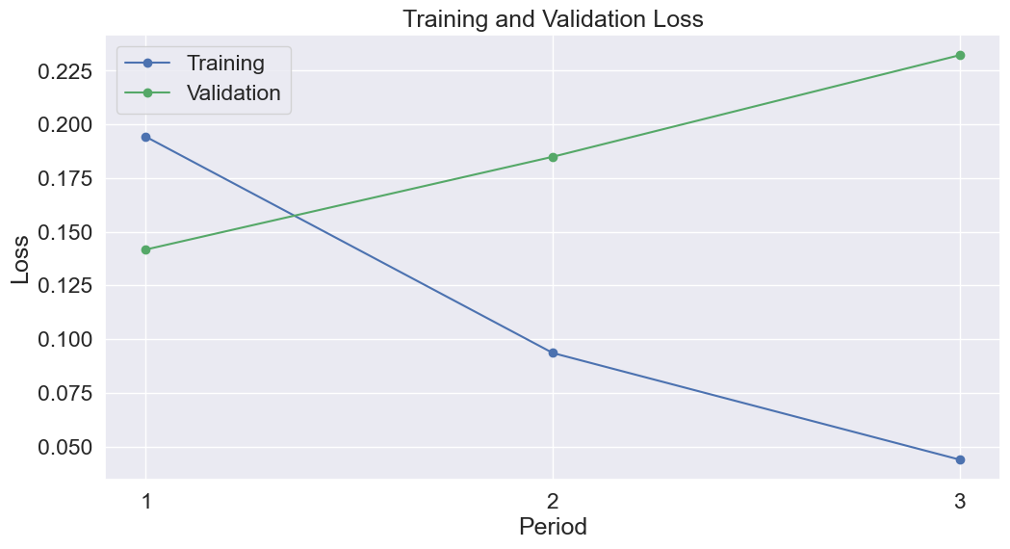
Model Evaluation
label
0 3418
1 2796
dtype: int64
Positive predicted Negative predicted
True positive 2640 156
True negative 170 3248
Accuracy in the test set: 94.7538%
Precision in the test set: 93.9502%
F1 score in the test set: 94.1848%
Sensitivity in the test set: 94.4206%
Specificity in the test set: 95.0263%

